Yeommi Cloudlands:
The planet Ularm is host to a race of flying bird-like creatures, and they have generously allowed the ACRO to build one of their tracks on the oddly floating yet organic environment of their homeworld. This has led the PAR organizers to dream up a very twisty, high flying track that allows the riders to really soar and see the fantastic floating islands and beautifully white landscapes and buildings that make up the planet. Most have agreed that it's sure to make for spectacular jumps and scenes.

Tracks:
- Okulan Highroads
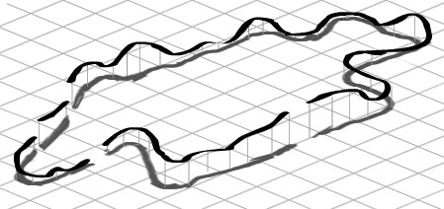
  - This bumpy course starts out right behind the edge of a large jump. The riders take off, shoot down the 45 degree decline through a cloudbank, and into a smooth right turn that straightaways into a gentle left curve, moving then into a mild decline before a sharp incline having several boost pads on it. The incline stops briefly, allowing the riders to get a grand view of the distance city area below them, then shoots down much like a roller coaster before moving into a gentle s-curve around some sparse buildings before straightening out into a small up and down area that takes them through a small thicket of alien trees before lifting up again, where there's a briefly decline, then a sharp turn to the left then right before straightening out into a series of jumps- between the large ground base they're on before wrapping around the last set of buildings and making a mighty leap towards the starting area to cross the finish line and end the lap.

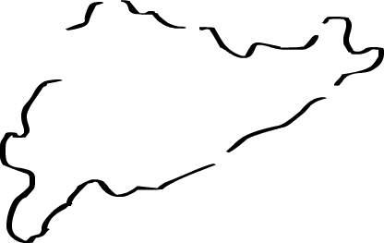
- Aeran Flightpath

  - (Abridged Description)
    - Track moves counter clockwise. Starts in the straightaway right above the word 'clockwise'. Lower the stretch of land after the jump a bit so as it can make a bit more sense. Basic idea is for the course to to run, hit a sharp turn, and have the riders begin ascending in a fashion so that they eventually hit a massive jump before hitting the start/finish line. Feel free to modify this course layout somewhat as you wish.

